Calculator App from cmauer69

Windows Desktop Version – with Simple calculations

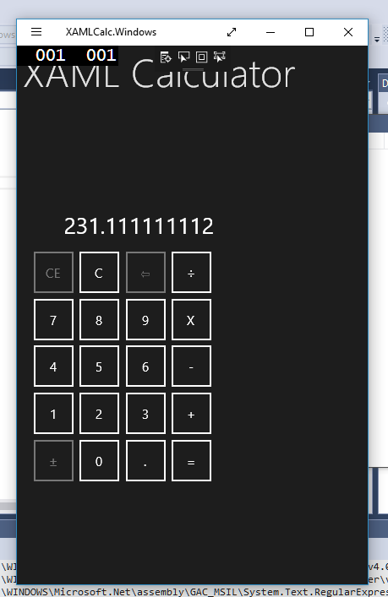

***Windows Phone version – Need to change the title and the way the blocks are displayed***

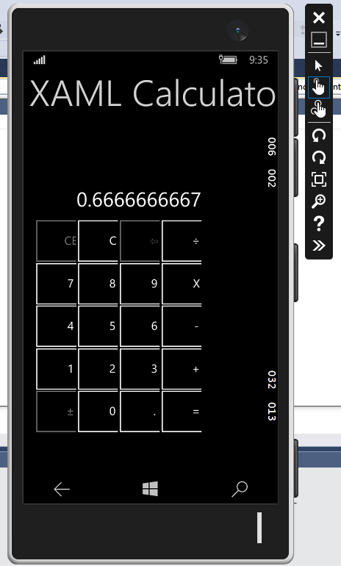

**Android version – This one looks the best.**

